A single entity
Although thinking in term of a single entity í great in theory, in many cases, the behaviors themselves may not be sent because both sides have copies of the code. However, it is important to think in terms of the entire object being sent across the network as a single entity.
Proper Design
A good example of this concept is an object that is loaded by a browser has no idea of what the object will do ahead of time because the code is not there previously. When the object is loaded, the browser executes the code within the object and uses the data contained within the object.

What exactly is an object
Objects are the building blocks of an OO program. A program that uses OO technology is basically a collection of objects. To illustrate, let’s consider that a corporate system contains objects that represent employees of that company. Each of these objects is made up of the data and behavior described in the following sections.
Object Data
The data stored within an object represents the state of the object. In OO programming terminology, this data is called attributes. In our example, as shown in Figure 1.6, employee attributes could be Social Security numbers, date of birth, gender, phone number, and so on. The attributes contain the information that differentiates between the various objects, in this case the employees. Attributes are covered in more detail later in this chapter in the discussion on classes.
Object behaviors
The behavior of an object represents what the object can do. In procedural languages the behavior is defined by procedures, functions, and subroutines. In OO programming terminology, these behaviors are contained in methods, and you invoke a method by sending a message to it. In our employee example, consider that one of the behaviors required of an employee object is to set and return the values of the various attributes. Thus, each attribute would have corresponding methods, such as setGender() and getGender(). In this case, when another object needs this information, it can send a message to an employee object and ask it what its gender is.
Not surprisingly, the application of getters and setters, as with much of object-oriented technology, has evolve since the first edition of this book was published. This is especially true when it comes to data. Remember that one of the most interesting, not to mention powerful, advantages of using ofjects is that the data is part of the package – it is not separated from the code.
The emergence of XML has not only focused attention on presenting data in a portable manner; it also has facilitated alternative ways for the code to access the data. In .NET techniques, the getters and setters are considered properties of the data itself.
For example, consider an attribute called Name, using Java that looks like the following:
“public String Name;”
The corresponding getter and setter would look like this:
“public void setName (String n) {name = n;};
Public String getName() {return name;};”

Now, when creating an XML attribute called Name, the definition in C# .NET may look something like this, akthough you can certainly use the same approach as Java example:
“private String strName;
Public String Name
{
Get { return this.strName; }
This.

The getter and setter are properties of the attributes, Name.
Regardless of the approach, the purpose is the same controlled access to the attribute. This chapter is concentrate on the conceptual nature of accessor method

Getters and Setters
The concept of getters and setters supports the concept of data hiding. Because other objects should not directly manipulate data within another object, the getters and setters provide controlled access to an object’s data. Getters and setters are sometimes called accessor methods and mutator methods, respectively.

This is only the interface of the methods; not the implementation. User only need to know to effectively use this method: The name of the method; the parameters passed to the method; the return type of the method

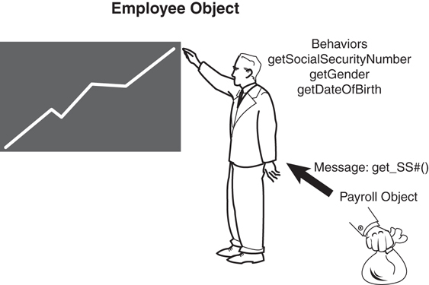
In the figure above, the Payroll object contains a method called CalculatePay() that calculates the pay for a specific employee. Among other information, the Payroll object must obtain the Social Security of this employee. To get this information, the payroll object must send a message to the employee object (in this case, the getSocialSecurityNumber() method). Basically this means that the Payroll object calls the getSocialSecurityNumber() method of the Employee object. The employee object recognizes the message and returns the requested information.
To illustrate further, Figure 1.8 is a class diagram representing the Employee/Payroll system we have been talking about
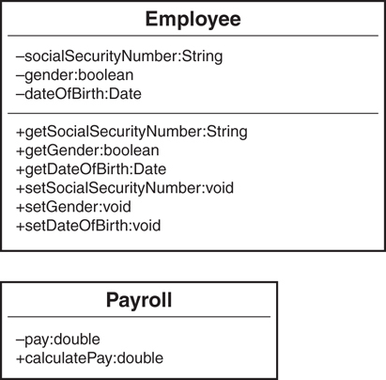
UML Class Diagrams
Because this is the first class diagram we have seen, it is very basic and lacks some of the constructs (such as constructors) that a proper class should contain. Fear not we will discuss class diagrams and contructors in more detail.

